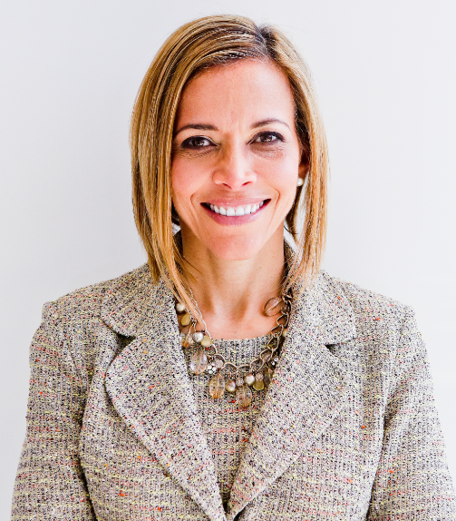 | Communicating with Impact  with  Dr. Ginny A. Baro
Dear WIND member,
​Welcome to your Training Resources!
This is your dynamic Workbook for our training on communicating with impact. We aim to support you in taking your communication skills to a new level and lead, engage, and influence your team and audiences powerfully. These strategies and resources are proven to achieve precisely that. Please take advantage of them.
No one else can do these exercises for you. You are empowered to prioritize working on them and focus on your self-development. Book yourself for 15 – 20 minutes at a time to work on the tools. You’ll gain clarity about your communication goals, how to know your audience, tailor your message, and pick your style. No more agonizing before a talk! You’ve got this.
Use your Resources page until December 2022: http://www.ExecutiveBound.com/wind23
Enjoy the journey and remember to contribute and lean on your peers for support. We’re only an email away.
Live with purpose, live with joy!
Coach Ginny
DR. GINNY A. BARO, CEO, ExecutiveBound™

1. COMMUNICATING WITH IMPACT
Being intentional about developing your communication skills will be one of the best investments in yourself. Let’s get clarity on where you are today and where you would like to grow as an impactful communicator. As you do, you’ll gain more confidence and collaboration skills, deliver results to help your organization and grow your career, enhance your brand, get buy-in, and become more influential.

- What are your communication strengths? Let’s get clear on what you love about your communication skills today. What are you most proud of?

- What did you learn from the training presentation that you can use to improve your communication? From the concepts I shared, which ones resonated with you the most?

- 12 months from now, you’ve improved your communication drastically. What happened? Get detailed about how you see yourself presenting, engaging, and leading your audience using the concepts we discussed in our training.
- Consider the next presentation you plan to give. Let’s prepare to deliver and facilitate an impactful talk by knowing your audience, tailoring your message, and picking your style:
- Know Your Audience. Meet their needs, become more impactful, contribute your strengths and influence positive results: Who is your audience? What are they interested in? What is their WIFM? (what’s in it for me?) What is their takeaway?
- Tailor Your Message. Focus on these factors as a starting point: Group, Age, Stories, Words, Context. Ensure that your message speaks to your audience’s interests and is relevant to their demographics and context. Then, consider, how can you leverage the framework “Heart, Head, Hands, Heart” to tailor your message for your next presentation?
- Pick your style. As you prepare, think about these factors: formal vs. casual, eye contact, body language, and voice. For your next presentation, what style would work best?
- What did you notice about yourself as you answered these questions? How easy or challenging was it for you? If you found it challenging, ask for support. It also helps to share your findings with trusted colleagues and WIND peers for accountability.

JOIN OUR COMMUNITY TO GAIN VALUABLE resources, strategies, AND TOOLS to help you REACH YOUR FULL POTENTIAL AND next level IN CAREER AND LIFE at www.executivebound.com
ABOUT DR. GINNY A. BARO, PHD, MBA, MS, CPC, CEO, FOUNDER AT EXECUTIVEBOUND

Dr. Ginny A. Baro, Ph.D., MBA, MS, CPC, immigrated to the U.S. at age 14 with nothing more than a dream. Today, she is an award-winning international transformational speaker, leadership coach, career strategist, and author with over three decades of experience in the corporate world. As the founder and CEO of ExecutiveBound™, Dr. Baro helps emerging executives by providing a unique approach to leadership development that is grounded on research, best practices, and lived experiences, which she uses to help her clients unlock their full potential.

Named one of the Top 100 Global Thought Leaders, Dr. Baro's expertise in leadership development has been recognized by Fortune 500 companies and partners, including McKinsey & Company, Verizon, Merck, and Pfizer, where she has been invited to speak numerous times on the topic. She has also been featured in numerous media outlets, including NBC, ABC, Fox, Univision, USA Today, Yahoo Finance, New York Business Journal, and Latinas in Business. She is a highly sought-after leadership coach and speaker for McKinsey & Company's Hispanic/Latino Executive Program and a subject matter expert on Personal Branding for the Management Accelerator since 2021.

Dr. Baro is the author of two best-selling books: Fearless Women at Work and Healing Leadership. Her books have been praised for their practical advice and actionable strategies. In 2020, Dr. Baro created the Fearless Leadership Mastermind™ to help high-potential female leaders of all backgrounds grow and advance. Her expertise, passion, and commitment to helping leaders and women make her an invaluable resource to any organization looking to unlock the full potential of their talent and achieve success in their business. To learn more, please visit www.ExecutiveBound.com.

Featured On

