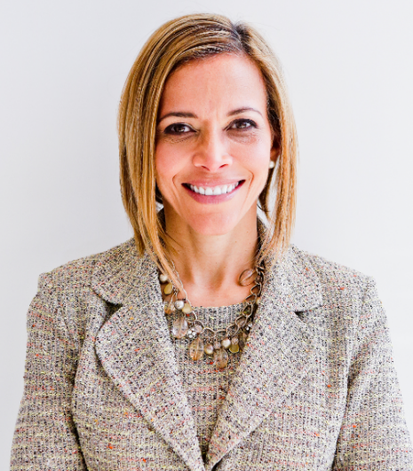 | How to Grow Your Value and Skills in a Hybrid Workplace without Burnout  with  Dr. Ginny A. Baro

Dear WAVE leader (sometimes in business and definitely in your own life),
​Congratulations on your commitment to growing in your professional development and advancing in your career.
This is your dynamic Workbook to complement our fireside chat on January 19, 2023.
You’ll learn a framework that gives you clear guidance to craft an engaging elevator pitch, practice it and tweak it until it feels natural to share it with your network.
Enjoy the journey, and remember to contribute and lean on each other for support. We’re only an email away.
Live with purpose, live with joy!
Coach Ginny
DR. GINNY A. BARO, CEO, ExecutiveBound®

THIS WORKBOOK BELONGS TO:
Name:

YOUR ELEVATOR PITCH

How would it serve you to have your ELEVATOR PITCH in your back pocket? It is a 1 – 2-minute engaging introduction to YOU that lets others know who you are, how you contribute, and what makes you tick. Use it when networking in person or virtually, attending a conference, joining a new group, connecting with a new mentor, sponsor, new colleague at work, etc. As you share it, you promote your personal brand and expertise and create potential opportunities for collaborations and growth. Have fun with it!

- Discover your Why: Write without sensoring yourself. After a few minutes of brainstorming, write a brief setence that describes “what makes you tick?”
- What do you live for?

- Here are the components of your LEVATOR PITCH. The color legend below points to each component.
Who are you?
What is your Why? (using your answer from A above)
What’s your expertise & who do you help?
What impact do you have (a recent win)?
What are you about outside of work? & Closing remark.

___ <greeting>! My name is ___, and I’m ___<title now> at <company name or dpt>. I have over ___ years of experience in the ___ industry/ies. I’m passionate about / I care about / My Why today is ___ <your Why>. My expertise is in / I specialize in ___<your top marketable skills, your superpowers, and who you do it for>. I ___ <impact you have/had>. In my spare time / When I’m not working, I enjoy ____. ____ <closing remark>. (It’s a pleasure to be here, to meet you, to be your guest, etc.)
Here’s my example:
“Hi, my name is Dr. Ginny Baro. I’m a transformational speaker, leadership coach, career strategies, and #1 bestselling author. I have over 25 years of experience in the financial services and technology industries. My Why today is to fulfill my full potential and to help my son and clients achieve theirs. I specialize in developing talented female leaders to grow and advance by delivering keynotes, coaching and leadership training programs for organizations, ERGs and Fortune 500s. In 2020, I created the Fearless Leadership Mastermind and graduated five cohorts so far! When I’m not working , I enjoy hiking, biking, meditating, traveling, and spending time with loved ones, especially my teenage son, Kyle, and Shih Tzu, Bruce. It’s a pleasure to be here.”

Write your answers below:

- ___ <greeting>! My name is ___, and I’m ___<title now> at <company name or dpt name>. I have over ___ years of experience in the ___ industry/ies.
- I’m passionate about / I care about / My Why today is ___ <your Why>. (your answer from the first question on this exercise)

- My expertise is in / I specialize in ___<your top marketable skills, your superpowers, and who you do it for>.

- I ___ <impact you have/had>. (Mention a recent “win”)
- On my spare time / When I’m not working, I enjoy ____. ____ <closing remark>. (It’s a pleasure to be here, to meet you, to be your guest, etc.)

- Let’s bring it all together. Combine answers 1 – 5 into one paragraph.

- Read your ELEVATOR PITCH out loud to yourself and to someone you trust at WAVE—who know this exercise. What doesn’t flow? Tweak it. When it feels more comfortable, underline the trigger phrases (to remind you how that sentence starts). Those are in BOLD in my example on pg. 3. Use any method you know to remember your trigger phrases. Then, share your pitch with your WAVE peers for “practice.” Tweak it as you see fit. Play it with. Keep practicing the final version. You’ve got this!
JOIN OUR COMMUNITY TO GAIN VALUABLE resources, strategies, AND TOOLS to help you REACH YOUR FULL POTENTIAL AND next level IN CAREER AND LIFE at www.executivebound.com/events
ABOUT DR. GINNY A. BARO, PHD, MBA, MS, CPC, CEO, FOUNDER AT EXECUTIVEBOUND

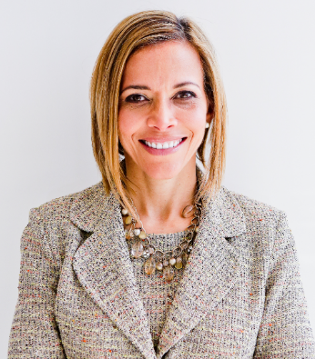  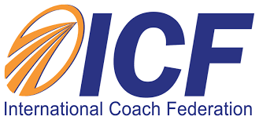 | Dr. Ginny Baro immigrated to the U.S. at age 14 with nothing more than a dream. Today, she is an award-winning international transformational speaker & leadership coach, career strategist, and #1 bestselling author of Healing Leadership and Fearless Women at Work. Named one of the Top 100 Global Thought Leaders, Dr. Baro has successfully delivered leadership training and coaching programs for Fortune 500 companies and keynotes impacting global audiences. She has been a leadership coach for McKinsey&Company's Hispanic/Latino Executive Leadership Program since 2021.  In 2020, Dr. Baro created the Fearless Leadership Mastermind™. Since then, the program has successfully helped talented female leaders in STEM fields, financial services, and Fortune 500 companies gain critical leadership skills to lead, engage, influence their teams, and advance in their roles. How? By design, it strategically leverages experiential, virtual mastermind circles within cohorts of up to 10 talented female peers for six months, executive group and individual coaching, mobile-friendly leadership training modules, personalized tools and assessments, accountability, community, and ongoing support for 12 months total.  She earned a Ph.D. in Information Systems, an MS in Computer Science, an MBA in Management, and a BA in Computer Science and Economics. She is a Certified Professional Coach (CPC) accredited by the International Coach Federation and is fluent in Spanish. To connect and learn more, please visit www.executivebound.com.

