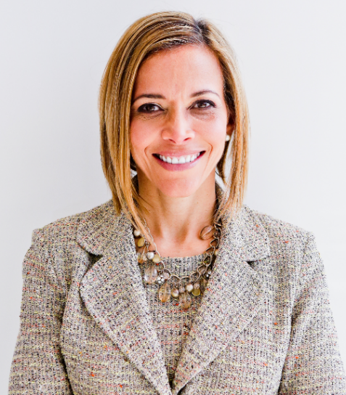 | Cultivating Strong Relationships, Mentors & Sponsors  with  Dr. Ginny A. Baro

Dear Rising Star,
Welcome to your training resources! And congratulations on committing to building a strong network of allies and advocates. It’s our pleasure to support you.

In this dynamic Workbook, we complement your training on Oct. 17, 2023, by helping you identify and connect with your Centers of Influence network. I encourage you to get together with trusted Circle peers and support each other to go through these tools. As you practice, you’ll tweak your approach, gain more confidence and momentum, and begin to see the improvements you desire 12-months from now.
Enjoy the experience of exploring your network today and envisioning what it could look like in a year to JDI (just do it!) and execute with a growth mindset, reframing challenges and setbacks as opportunities to learn.
We believe in you and your ability to reach your full potential.
Use your private resources page until Dec. 31, 2023: https://ExecutiveBound.com/wind23
Life’s a journey. Remember to contribute using your superpowers and lean on each other for guidance and emotional support. Our team is only an email away.
Live with purpose, live with joy!
Coach Ginny
DR. GINNY A. BARO, CEO, ExecutiveBound®

1. YOUR CENTERS OF INFLUENCE DIAGRAM
Use this tool to identify your “Centers of Influence Diagram” and professional network. Follow through and engage with them proactively, regularly, and intentionally. Shift from being “transactional” to being “relational” and you’ll expand your “army of allies,” support network, and advocates to grow and increase your impact.
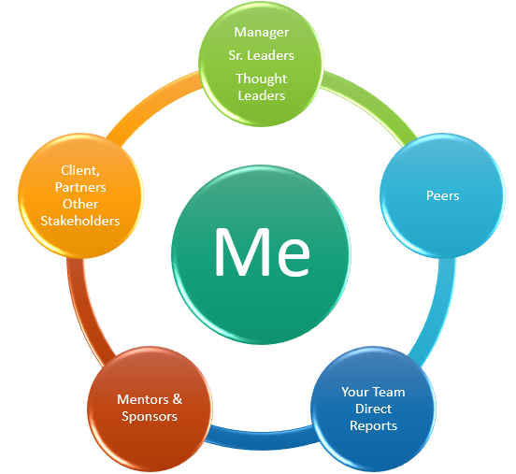
- Using the above diagram as a guide, use the next page to draw your personalized Centers of Influence diagram using the names or person’s initials that belong in each circle.
Manager, Sr. Leaders, Thought Leaders | Include your manager and other senior leaders in the organization connected to your function or who you can learn from about the business, how it runs, the vision, etc.
Peers | Who are your peers within your team or those in other departments with whom you interact? Having them in your corner is meaningful.
Your Team | Who are your direct reports, or others significant stakeholders at this level of the organization who support your team? (e.g., any matrix reporting teams)
Sponsors/Mentors | Who are your sponsors? These senior leaders can assign you an initiative, advocate for your promotion into a new role, and make it happen. Who are your mentors? They serve as advisors; you trust their guidance and direction, and they can make introductions to others in the company or industry, for example.
Other Stakeholders | List any critical influencers in the organization or outside who interface with your role. They can be your advocates or promote your good work to others based on how WELL they know you.
Start drawing your Centers of Influence network map below. Notice how they form a “ring” of protection—your army of allies:

- On a scale of 1 to 10, how well do you engage and build relationships with your target audience or desired network?
Questions for reflection post training:
- What did you notice as you built your network diagram? What do you commit to yourself to do after today? What is possible 12 months from now?
- Did you find any “gaps” in one or more areas? Which ones?
- How healthy are your sponsor & mentor relationships? Who do you admire / appreciate as a leader / are curious about? Those could become sponsor/ mentors.
- Who do you know who can support you in developing those relationships?
- What ideas come to mind when considering connecting with the people on your diagram? Jot them down here.
- Pick one or two people to connect with weekly, monthly, or quarterly.
- Mark your calendar to reach out to them and set up a 15-minute live or cyber-coffee or tea. Slow and steady wins the race. Be fearless (act despite the fear).

2. BONUS ASSESSMENT: EXECUTE WITH A GROWTH MINDSET
What typically holds you back from JDI (just doing it!) and taking action, following through, and going after your goals? E.g., building strong relationships, mentors, and sponsors? Let’s find out.
On a scale of 1 to 5, please rate the following statements based on how strongly they hold you back from “just doing it” with a growth mindset. When done, add up your scores first, and then read the interpretations and answer the questions on the next page.

Barriers | On a scale from 1 – 5 | Your Score Pick 1 – 5
- Fear of Failure | 1 = Not at all fearful of failure, readily embrace new challenges  5 = Extremely fearful of failure, tend to avoid taking risks
- Fixed Mindset | 1 = Believe that abilities and intelligence can grow with effort  5 = Believe that abilities and intelligence are fixed traits
- Perfectionism | 1 = I’m comfortable with making mistakes and learning from them  5 = Strong urge to avoid making any mistakes or failures
- Procrastination: | 1 = Able to start tasks promptly without delay  5 = Frequently postpone or avoid starting tasks
- Self-Doubt | 1 = High self-confidence in pursuing goals, even in uncertain situations  5 = Constantly doubt own abilities and second-guess decisions

BONUS ASSESSMENT - Interpretation of Overall Scores

- If your overall score ranges from 5 to 10:
You exhibit a strong growth mindset and are not significantly held back by barriers. Congratulations!

- If your overall score ranges from 11 to 15:
You have some barriers to overcome, but with conscious effort, you can further develop your growth mindset. You can benefit from exploring these barriers and actively seeking support to overcome them.

- If your overall score ranges from 16 to 25:
You have identified several significant barriers that may be holding you back from making progress and executing with a growth mindset. You can benefit from exploring these barriers and actively seeking support to overcome them.
- What did you discover from this self-assessment?
- What are some ideas to JDI - execute with a growth mindset based on what you learned during our training: Cultivating Strong Relationships, Mentors & Sponsors?
- What resources can you lean on for support?

JOIN OUR COMMUNITY TO GAIN VALUABLE resources, strategies, AND TOOLS to help you REACH YOUR FULL POTENTIAL AND next level IN CAREER AND LIFE at www.executivebound.com
ABOUT DR. GINNY A. BARO, PHD, MBA, MS, CPC, CEO, FOUNDER AT EXECUTIVEBOUND

Dr. Ginny A. Baro, Ph.D., MBA, MS, CPC, immigrated to the U.S. at age 14 with nothing more than a dream. Today, she is an award-winning international transformational speaker, leadership coach, career strategist, and author with over three decades of experience in the corporate world. As the founder and CEO of ExecutiveBound™, Dr. Baro helps emerging executives by providing a unique approach to leadership development that is grounded on research, best practices, and lived experiences, which she uses to help her clients unlock their full potential.

Named one of the Top 100 Global Thought Leaders, Dr. Baro's expertise in leadership development has been recognized by Fortune 500 companies and partners, including McKinsey & Company, Verizon, Merck, and Pfizer, where she has been invited to speak numerous times on the topic. She has also been featured in numerous media outlets, i.e., NBC, ABC, Fox, Univision, USA Today, Yahoo Finance, New York Business Journal, and Latinas in Business. She is a highly sought-after leadership coach and speaker for McKinsey & Company's Hispanic/Latino Executive Program and a subject matter expert on Personal Branding for the Management Accelerator since 2021.

Dr. Baro is the author of two best-selling books: Fearless Women at Work and Healing Leadership. Her books have been praised for their practical advice and actionable strategies. In 2020, Dr. Baro created the Fearless Leadership Mastermind™ to help high-potential female leaders of all backgrounds grow and advance, and has graduated five cohorts thus fas! Her expertise, passion, and commitment to helping leaders and women make her an invaluable resource to any organization looking to unlock the full potential of their talent and achieve success in their business. To learn more, please visit www.ExecutiveBound.com.

Featured On

