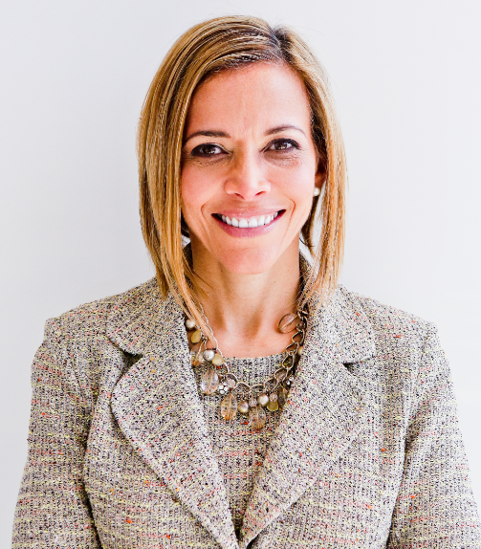 | Reclaiming Your Why to Achieve Career Goals without Burnout  with  Dr. Ginny A. Baro
Dear LATINOS COMMUNITY member,
​Welcome to your Training Resources!
This is your dynamic Workbook for our training on September 29, 2022 to reclaim your Why and pursue meaningful career goals without burning the candle on both ends. If you missed the first training, please download the presentation’s PDF and review what we covered.
No one else can do these exercises for you. You are empowered to prioritize working on them and focus on your self-development. Book yourself for 15 minutes at a time to work on the tools. You’ll gain clarity about your Why and career goals today, craft your Elevator Pitch to use during networking opportunities within your organization and externally, and clarify opportunities for more Self-care.
Use your Resources page until December 2022: http://www.ExecutiveBound.com/latino22
Enjoy the journey and remember to contribute and lean on your LATINOS COMMUNITY peers for support. We’re only an email away.
Live with purpose, live with joy!
Coach Ginny
DR. GINNY A. BARO, CEO, ExecutiveBound™

Workbook Table of Contents

1. WHAT IS YOUR WHY TODAY? 1
2. WHAT ARE YOUR CAREER GOALS TODAY? 3
3. YOUR ELEVATOR PITCH 4

THIS WORKBOOK BELONGS TO:
Name: |  | Date:

1. WHAT IS YOUR WHY TODAY?
Getting clear on your Why today will bring you many benefits, including: 1) use it to fuel you & make career and life decisions, 2) stay focused & productive on career goals, 3) avoid overwhelm & “spinning plates,” 4) reduce anxiety & self-doubt, 5) share it to create new opportunities, 6) engage others on your mission & vision,7) take personal responsibility for your dreams, to name a few.
- Option 1: What do you live for? Being honest with yourself, explore by writing down your “gut” answer. This is for you, don’t hold back. What you live for is your “Why” today.

- What gets in the way of what you live for? Answering this question will point you to what to look at closer to remove or reduce to bring your closer to living more aligned with your Why.

Option 2: Let’s play a game! I’m going to ask you the same question multiple times, and each time we’re going to go deeper and deeper. Invite a trusted peer in this training to do this exercise together. Find a quiet, private place, and let’s do this!
Why do you want to be successful in life? Answer succinctly.
Answer.
- Why is answer above important to you? Answer succinctly.

Answer #1
- Why is answer #1 important to you? Answer succinctly.

Answer #2
- Why is answer #2 important to you? Answer succinctly.

Answer #3
- Why is answer 3 important to you? Answer succinctly.

Answer #4
- Why is answer #4 important to you? Answer succinctly.

Answer #5
- Why is answer #5 important to you? Answer succinctly.

Answer #6
- Why is answer #6 important to you? Answer succinctly.

Answer #7

Write a Why statement using your answer to #7:
My Why today is Answer #7.
What did you notice about where you started with your first answer for Option 1 and where you ended up with Answer #7, for Option 2? What’s the difference, if any? Which of the two options feels most aligned to your Why today?

2. WHAT ARE YOUR CAREER GOALS TODAY?
Over time, we can lose sight of meaningful career goals and we get into “survival moved.” To re-discover them, let’s focus now on a visualization exercise that will help you identify your career goals for the next 12 months. Knowing these will support you to feel inspired, energized, and motivated to pursue activities that will move the needle in your career. After you identify “what happened?” ask yourself, why is that goal important to me? Invite a trusted peer in this training to do this exercise together. Find a quiet, private place, and let’s do this!
- Imagine you and I are meeting 12 months from now, and you’ve had a WILDLY SUCCESSFUL YEAR—the best of your career yet! What happened? Share with me in detail what you achieved, how you showed up, how you felt, what you and the team accomplished, the impact you had, how you contributed, etc. Write it down in the past tense, as if these already happened! (because they have! 😉)

- What happened 1
- What happened 2
- What else happened? Etc. Keep asking what else happened until you can’t think of anything else.
- For example, I got promoted to the next role and now earn 15% more; I completed xyz initiative successfully and the team was re-energized; I set boundaries and ended work by 6 PM most weekdays; I spent quality time with the family with all devices “off.” I learned about derivatives and supported my team by answering related questions, etc.
- For the list of goals you created in answer #1, please describe briefly Why these goals are important to you. The ones that don’t have a significant enough “Why,” cross them off. The rest remain on your list of compelling goals for the next 12 months.

- Why is goal 1 important
- Why is goal 2 important
- Etc.
- For example, by reaching the next role, I can contribute at a more strategic level and influence where we go as a team. The extra income helps the family save for college and enjoy a family summer vacation, etc.

- What did you notice as you answered these questions? Reflections are valuable to increase your self-awareness, one of the components of emotional intelligence. How easy or challenging was it for you to work on these answers? If you found it challenging or want accountability, get support from trusted colleagues, LATINO COMMUNITY peers, or your coach.

3. YOUR ELEVATOR PITCH
When you are networking, attending a conference, joining a new group, or connecting with someone through work, how helpful would it be to have your elevator pitch in your back pocket? It is a 1 – 2-minute introduction to you that lets others know what you do, the value you add, and what you enjoy about your role. As you share it, you promote your personal brand, expertise, and create potential opportunities for collaborations and growth. That’s what we’re going to do next. Enjoy the journey!
- Who are you?
- What is your Why?
- What’s your expertise & who do you help?
- What impact do you have (a recent win)?
- What are you about outside of work?
After crafting your pitch below, read it out loud, and tweak it, so it sounds natural. Then, remember the start of each sentence (in bold in my example below) to use as a “trigger” to remind you what’s next as you practice your pitch with trusted friends. The color legend below points to each component of the pitch.
___ <greeting>! My name is ___, and I’m ___<title now> at <company name or dpt>. I have over ___ years of experience in the ___ industry/ies. I’m passionate about / I care about / My Why today is ___ <your Why>. My expertise is in / I specialize in ___<what you get paid to do, your superpowers, and who you do it for>. I ___ <impact you have/had>. On my spare time / When I’m not working, I enjoy ____. ____ <closing remark>. (It’s a pleasure to be here, to meet you, to be your guest, etc.)
Here’s my example:
“Hi, my name is Dr. Ginny Baro. I’m an international transformational speaker, leadership coach, career strategies, and #1 bestselling author. I have over 25 years of experience in the financial services and technology industries. My Why today is to fulfil my full potential and to help my son Kyle and clients achieve theirs. I specialize in delivering keynotes, coaching and leadership training programs for organizations, ERGs and Fortune 500 companies to help leaders drive business growth and high-performing teams without burning out. In 2020, I created the Fearless Leadership Mastermind program, which has helped female leaders in STEM fields and financial services advance within their companies. So far, we’ve graduated five cohorts! When I’m not working, which is most of the time , I enjoy hiking, biking, meditating, traveling, and spending time with my teenage son, family, and friends. It’s a pleasure to be here.”
What did you notice as you crafted your elevator pitch? What was easy or challenging? How willing are you to practice this elevator pitch with trusted friends? As you do, come back to it and tweak it.

JOIN OUR COMMUNITY TO GAIN VALUABLE resources, strategies, AND TOOLS to help you REACH YOUR FULL POTENTIAL AND next level IN CAREER AND LIFE at www.executivebound.com
ABOUT DR. GINNY A. BARO, PHD, MBA, MS, CPC, CEO, FOUNDER AT EXECUTIVEBOUND

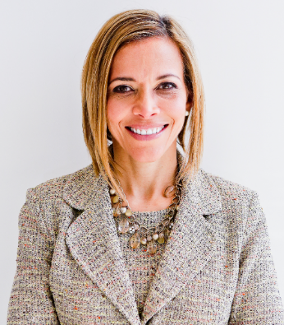  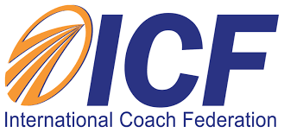  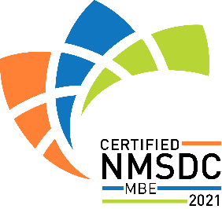 | Dr. Ginny Baro immigrated to the U.S. at age 14 with nothing more than a dream. Today, she is an award-winning international transformational speaker & leadership coach, career strategist, and #1 bestselling author of Healing Leadership and Fearless Women at Work. Named one of the Top 100 Global Thought Leaders, Dr. Baro has successfully delivered leadership training and coaching programs for Fortune 500 companies and keynotes impacting global audiences. She has been a leadership coach for McKinsey&Company's Hispanic/Latino Executive Leadership Program since 2021.  In 2020, Dr. Baro created the Fearless Leadership Mastermind™. Since then, the program has successfully helped talented female leaders in STEM fields, financial services, and Fortune 500 companies gain critical leadership skills to lead, engage, influence their teams, and advance in their roles. How? By design, it strategically leverages experiential, virtual mastermind circles within cohorts of up to 10 talented female peers for six months, executive group and individual coaching, mobile-friendly leadership training modules, personalized tools and assessments, accountability, community, and ongoing support for 12 months total.  She earned a Ph.D. in Information Systems, an MS in Computer Science, an MBA in Management, and a BA in Computer Science and Economics. She is a Certified Professional Coach (CPC) accredited by the International Coach Federation and is fluent in Spanish. To connect and learn more, please visit www.executivebound.com.

