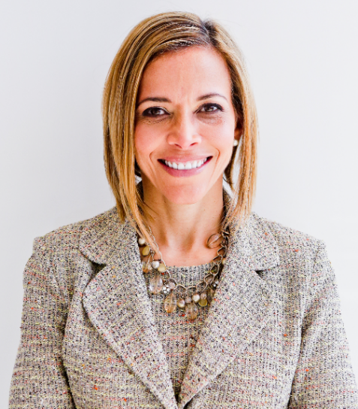 | Building Relationships to Advance Your Career: Mentors and Sponsors Matter  with  Dr. Ginny A. Baro

Dear HOLA leader (sometimes in business and definitely in your own life),
Welcome to your Training Resources! And congratulations on your commitment to growing professionally! It’s my pleasure to celebrate Hispanic Heritage Month with you.
This is your dynamic Workbook to complement our training on October 11, 2022. If you missed the live training, please refer to the session’s recording, and download the Workbook and Companion Guide to benefit the most from the event.
I want you to know that you are empowered to prioritize working on yourself and focus on your professional development. No one else can do these exercises for you. Please set aside 15 – 20 minutes to work on the tools and review the Companion Guide for best practices as you seek mentors and sponsors and grow your “army of allies.” If you find it more enjoyable, enlist an HOLA peer to work on the exercises together.
Use your Resources page until December 2022: http://www.ExecutiveBound.com/hola
Enjoy the journey, and remember to contribute and lean on your community of ERG peers for support. We’re only an email away.
Live with purpose, live with joy!
Coach Ginny
DR. GINNY A. BARO, CEO, ExecutiveBound®

Workbook Table of Contents

1. YOUR CENTERS OF INFLUENCE DIAGRAM 3

THIS WORKBOOK BELONGS TO:
Name: |  | Date:

YOUR CENTERS OF INFLUENCE DIAGRAM
Use this tool to identify your “Centers of Influence” in your professional world. Engage with them proactively and connect with them periodically and intentionally. Shift from being “transactional” to being “relational” and you’ll expand your “army of allies,” support network and advocates. The relationships you build nurture:
- Help you promote your goals and personal brand
- Enhance your influence, impact, and well-being
- Contribute to your professional growth (i.e., new roles, mentors, sponsors, new clients)
- Increase your sense of connection and belonging—a human need
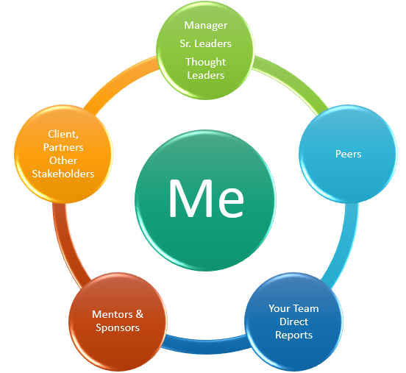
- Using the above diagram as a guide, use the next page to draw your personalized Centers of Influence diagram using the names or person’s initials that belong in each circle.
Manager, Sr. Leaders, Thought Leaders | Include your manager and other senior leaders in the organization connected to your function or who you can learn from about the business, how it runs, the vision, etc.
Peers | Who are your peers within your team or those in other departments with whom you interact? Having them in your corner is meaningful.
Your Team | Who are your direct reports, or others significant stakeholders at this level of the organization who support your team? (e.g., any matrix reporting teams)
Mentors / Sponsors | Who are your mentors? They serve as advisors; you trust their guidance and direction, and they can make introductions to others in the company or industry, for example. Who are your sponsors? These senior leaders can assign you an initiative, advocate for your promotion into a new role, and make it happen.
Other Stakeholders | List any critical people who are influencers in the organization or outside who interface with your role. They can be your advocates or promote your good work to others based on how they know you.

Draw your Centers of Influence diagram below. Notice how they form a “ring” of protection—your army of allies:

- What did you notice as you built your diagram?
- Did you find any “gaps” in one or more areas? Which ones?
- How healthy are your sponsor & mentor relationships? Who do you admire / appreciate as a leader / are curious about? Those could become mentors / sponsors.
- Who do you know who can support you in developing those relationships?
- What ideas come to mind when considering connecting with the people on your diagram? Jot them down here.
- Pick one or two people to connect with weekly, monthly, or quarterly.
- Mark your calendar to reach out to them and set up a 15-minute live or cyber-coffee or tea. Slow and steady wins the race. Be fearless (act despite the fear).

JOIN OUR COMMUNITY TO GAIN VALUABLE resources, strategies, AND TOOLS to help you REACH YOUR FULL POTENTIAL AND next level IN CAREER AND LIFE at www.executivebound.com
ABOUT DR. GINNY A. BARO, PHD, MBA, MS, CPC, CEO, FOUNDER AT EXECUTIVEBOUND

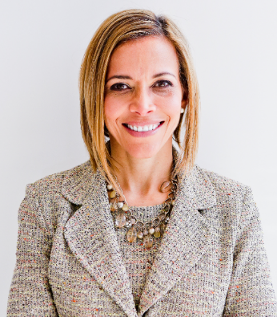  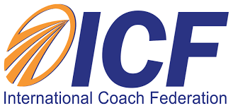  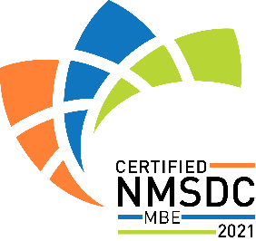 | Dr. Ginny Baro immigrated to the U.S. at age 14 with nothing more than a dream. Today, she is an award-winning international transformational speaker & leadership coach, career strategist, and #1 bestselling author of Healing Leadership and Fearless Women at Work. Named one of the Top 100 Global Thought Leaders, Dr. Baro has successfully delivered leadership training and coaching programs for Fortune 500 companies and keynotes impacting global audiences. She has been a leadership coach for McKinsey&Company's Hispanic/Latino Executive Leadership Program since 2021.  In 2020, Dr. Baro created the Fearless Leadership Mastermind™. Since then, the program has successfully helped talented female leaders in STEM fields, financial services, and Fortune 500 companies gain critical leadership skills to lead, engage, influence their teams, and advance in their roles. How? By design, it strategically leverages experiential, virtual mastermind circles within cohorts of up to 10 talented female peers for six months, executive group and individual coaching, mobile-friendly leadership training modules, personalized tools and assessments, accountability, community, and ongoing support for 12 months total.  She earned a Ph.D. in Information Systems, an MS in Computer Science, an MBA in Management, and a BA in Computer Science and Economics. She is a Certified Professional Coach (CPC) accredited by the International Coach Federation and is fluent in Spanish. To connect and learn more, please visit www.executivebound.com.

