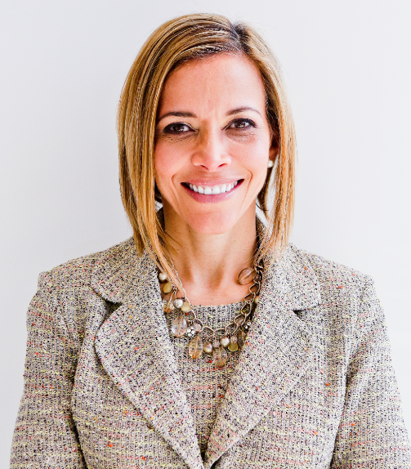 | 6 Strategies to Develop Leadership Skills & Shift from Surviving to Thriving  with  Dr. Ginny A. Baro
Dear UNIDOS member,
​Welcome to your Training Resources!
This is your dynamic Workbook for the second training with valuable tools to “Become an Expert” and “Invest in Yourself,” the two strategies we discussed on September 27, 2022, to develop leadership skills and shift from surviving to thriving. On October 27, 2022, we’ll cover the last two strategies: Trust the process and master multiple areas of your life. If you missed the first training on August 13, 2022, please download the Workbook and presentation from your Resources page and take advantage of it.
No one else can do this for you. You have the power to prioritize working on your self-development for 15 minutes at a time to work on the tools. You’ll gain clarity that will support you to continue growing in your role, leadership skills, and impact without burning out.
Use your Resources page until December 2022: http://www.ExecutiveBound.com/unidos22
Enjoy the journey and remember to contribute and lean on your UNIDOS peers for support. We’re only an email away.
Live with purpose, live with joy!
Coach Ginny
DR. GINNY A. BARO, CEO, ExecutiveBound™

Workbook Table of Contents

1. BECOME AN EXPERT 3
2. INVEST IN YOURSELF 4

THIS WORKBOOK BELONGS TO:
Name: |  | Date:

1. BECOME AN EXPERT
To increase your value to the organization, become an expert in your role. Look to contribute to the best of your ability. Zoom out to see what the business is really about. Insert yourself in the middle of core business activities, and build relationships up, down, and sideways, like your life and career depend on it because they do! And finally, do what you need to retool. Let’s shift our focus on your expertise and how to take it to new heights.
- Explore your talent. Go deep & get better at it. What does it look like for you today to explore your talent? How do you contribute to your role? What interests you? Highlight what you love about your expertise. What can you do or explore to double down or go deeper to improve upon what you do and how you do it?

- Tap into your potential. What can it look like for you to develop your intellectual, emotional, and spiritual capital? Focus on what you enjoy and what you also have a talent for. How can you commit to taking action toward the outcomes you want? Once you focus on WHAT you want, being flexible about “HOW” it will happen can support you to become more resourceful and open to embracing solutions that you may not have considered.

- Retool. What would it look like to get out of your comfort zone and retool? About 80% of people stay in their comfort zone. How would you feel while you retool and afterward? What resources do you need, and who can you ask for support?

- What did you notice as you answered these questions? How easy or challenging was it for you?

2. INVEST IN YOURSELF
Investing in yourself means that you believe in your abilities and potential. It means you are willing to do what it takes to go after your dreams today and to enjoy the journey along the way—that’s how we shift from surviving to thriving. I believe that all of it is the “journey.” Happiness, joy, and fulfillment result from being present and acknowledging the journey, living with purpose, and feeling aligned with your values and vision. Let’s gain more clarity about how to invest in yourself and bring your vision to reality. I believe in you.
- What actions do you need to perform to bring your vision & ideas to reality? What would it look like to put your plan in place (with flexibility)? How will you need to invest in yourself (time, effort, financially, emotionally)? Recall what you envisioned would happen in your wildly successful year (training #1 in August 2022).

- How would taking these actions disrupt your life, and how would it be fulfilling? Let’s be realistic about how you foresee your life changing due to investing in yourself. Acknowledging this and how fulfilling it would be can inspire you to go for it. If you feel overwhelmed, ask for help.

- How will you enjoy the fruits of your hard work? “Work hard, play harder” is a common expression. Rewarding and acknowledging yourself helps you create and keep a positive momentum loop. In what small ways (or big ones) can you celebrate and enjoy the journey?

- What did you notice as you answered these questions? How easy or challenging was it for you?

JOIN OUR COMMUNITY TO GAIN VALUABLE resources, strategies, AND TOOLS to help you REACH YOUR FULL POTENTIAL AND next level IN CAREER AND LIFE at www.executivebound.com
ABOUT DR. GINNY A. BARO, PHD, MBA, MS, CPC, CEO, FOUNDER AT EXECUTIVEBOUND
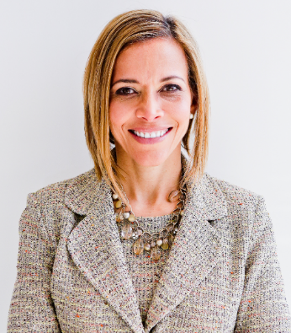  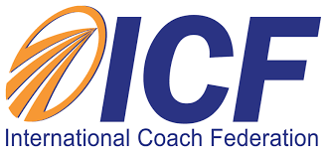  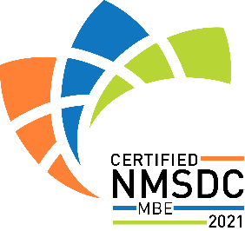  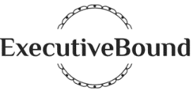 | Dr. Ginny Baro immigrated to the U.S. at age 14 with nothing more than a dream. Today, she is an award-winning international transformational speaker & leadership coach, career strategist, and #1 bestselling author of Healing Leadership and Fearless Women at Work. Named one of the Top 100 Global Thought Leaders, Dr. Baro has successfully delivered leadership training and coaching programs for Fortune 500 companies and keynotes impacting global audiences. She has been a leadership coach for McKinsey&Company's Hispanic/Latino Executive Leadership Program since 2021.  In 2020, Dr. Baro created the Fearless Leadership Mastermind™. Since then, the program has successfully helped talented female leaders in STEM fields, financial services, and Fortune 500 companies gain critical leadership skills to lead, engage, influence their teams, and advance in their roles. How? By design, it strategically leverages experiential, virtual mastermind circles within cohorts of up to 10 talented female peers for six months, executive group and individual coaching, mobile-friendly leadership training modules, personalized tools and assessments, accountability, community, and ongoing support for 12 months total.  She earned a Ph.D. in Information Systems, an MS in Computer Science, an MBA in Management, and a BA in Computer Science and Economics. She is a Certified Professional Coach (CPC) accredited by the International Coach Federation and is fluent in Spanish. To connect and learn more, please visit www.executivebound.com.

