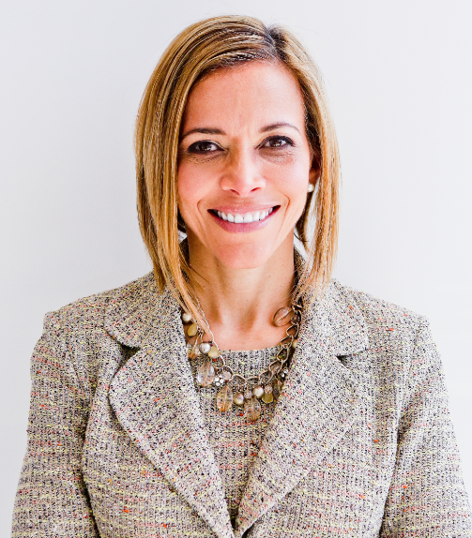 | 6 Strategies to Develop Leadership Skills & Shift from Surviving to Thriving  with  Dr. Ginny A. Baro
Dear UNIDOS member,
​Congratulations and welcome to your Training Resources!
We’ve made it! This Workbook is your third one corresponding to the last training of 2022. This Workbook covers strategies five and six, Trust the Process and Master Multiple Areas of Your Life.
The six strategies we covered during all three sessions appear in Section 3, Strategies for Personal Development, in our #1 bestselling book, Healing Leadership: How to Lead, Love, and Thrive in Business and Life.
If you missed the first or second training on August 13th and September 27th, respectfully, please download the Workbooks and presentations from your Resources page and take advantage of this valuable training.
Prioritize working on your personal and professional development. You’ll gain much-needed clarity that will support you in mapping out a clear roadmap for 2023! You have so much potential; we’re here to help you share it with all of us, increase your value to the organization, and feel a sense of belonging and support. #togetherwerise
Use your Resources page until December 2022: http://www.ExecutiveBound.com/unidos22
I encourage you to support your UNIDOS peers and raise your hand to increase your visibility in a leadership role within UNIDOS if that speaks to you. We’re only an email away.
Live with purpose, live with joy!
Coach Ginny
DR. GINNY A. BARO, CEO, ExecutiveBound™

Workbook Table of Contents

1. TRUST THE PROCESS 3
2. MASTER MULTIPLE AREAS OF YOUR LIFE 4

THIS WORKBOOK BELONGS TO:
Name: |  | Date:

1. TRUST THE PROCESS
Let’s clarify some significant obstacles preventing you from developing leadership skills and shifting from surviving to thriving.
- What challenges do you face when trying to implement the strategies we’ve discussed? Be very honest with yourself. No one will see your answers.
- Bet on Yourself: Get clear on your compelling vision & goals
- Create Opportunities: Make continuous learning your new norm
- Become an Expert: Explore your talent; Tap into your potential; Retool
- Invest in Yourself: Do what it takes; Capitalize on your hard work—enjoy the journey!
- Trust the Process: Account for the “time” factor; Stay the course

- What are you proud of regarding these strategies? In other words, what do you want to acknowledge and celebrate about yourself?

- With this level of self-awareness, what is possible from here?
- Which challenges are self-imposed?
- If you were to focus on a specific strategy, which would support you the most in the future?
- Who can help you overcome these most meaningful challenges that will continue to hold you back otherwise? Let’s get creative and resourceful. Incorporate action steps from this answer in your action plan for 2023! (Yes, create a plan for 2023! LOL)

2. MASTER MULTIPLE AREAS OF YOUR LIFE
In looking at your life holistically, you have an opportunity to zoom out and explore what’s happening. Let’s get clear on what’s going on in the different areas of your Wheel of Life. Notice how having this new level of self-awareness will support you to lead yourself more powerfully and shift into a more empowering way of living and working.
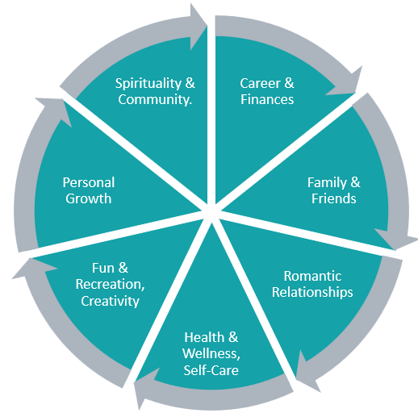

Master Multiple Areas of Your Life: We spoke about intentionally creating a supportive structure and integrating work and life.

- Go through the areas in your Wheel of Life above and assess:
- Which areas am I doing very well in? What am I doing to make it so?
- Which areas do I struggle with? How would I feel if I made enhancements in those areas?
- Which areas bring me the most joy? (focus on the ones that do, and explore what could be the source of the crunchiness for the ones that don't)

- What are you committing to today to integrate these areas more gracefully? This intention will help you in creating the supportive structure you need to make it happen, including enlisting others in your vision and asking for their support in making it happen.

JOIN OUR COMMUNITY TO GAIN VALUABLE resources, strategies, AND TOOLS to help you REACH YOUR FULL POTENTIAL AND next level IN CAREER AND LIFE at www.executivebound.com
ABOUT DR. GINNY A. BARO, PHD, MBA, MS, CPC, CEO, FOUNDER AT EXECUTIVEBOUND
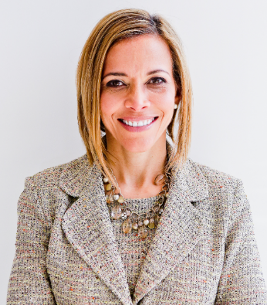  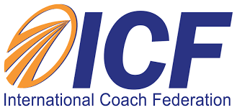  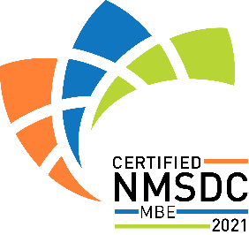  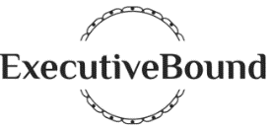 | Dr. Ginny Baro immigrated to the U.S. at age 14 with nothing more than a dream. Today, she is an award-winning international transformational speaker & leadership coach, career strategist, and #1 bestselling author of Healing Leadership and Fearless Women at Work. Named one of the Top 100 Global Thought Leaders, Dr. Baro has successfully delivered leadership training and coaching programs for Fortune 500 companies and keynotes impacting global audiences. She has been a leadership coach for McKinsey&Company's Hispanic/Latino Executive Leadership Program since 2021.  In 2020, Dr. Baro created the Fearless Leadership Mastermind™. Since then, the program has successfully helped talented female leaders in STEM fields, financial services, and Fortune 500 companies gain critical leadership skills to lead, engage, influence their teams, and advance in their roles. How? By design, it strategically leverages experiential, virtual mastermind circles within cohorts of up to 10 talented female peers for six months, executive group and individual coaching, mobile-friendly leadership training modules, personalized tools and assessments, accountability, community, and ongoing support for 12 months total.  She earned a Ph.D. in Information Systems, an MS in Computer Science, an MBA in Management, and a BA in Computer Science and Economics. She is a Certified Professional Coach (CPC) accredited by the International Coach Federation and is fluent in Spanish. To connect and learn more, please visit www.executivebound.com.

