Communicate Powerfully
Workbook
with
Dr. Ginny A. Baro

Dear PWR member,
​Welcome to your Training Resources! Congratulations on your commitment to taking your communication to the next level.
This is your personalized, dynamic Workbook to help you communicate powerfully, with intention, authenticity, and purpose. Use it to plan a specific talk and prepare effectively. Type in your answers in the Workbook and keep it handy for future reference.

By engaging with these exercises, you’ll have clear direction to craft a compelling talk, engage your audience meaningfully, promote a positive personal brand, gain more opportunities, and grow in your career and life in the process.

Promise yourself (and then be impeccable with your world) that you will allocate time in your calendar to prioritize working on these valuable exercises. Without this level of intention, you will delay getting the results you want indefinitely.

Today, claim that you are a powerful communicator and begin taking the next step in that direction. Your belief will provide confidence and resolve to do what it takes to make it so. Then, the rest will unfold—you are in the driver’s seat of your life.

You will have access to your private page (http://www.ExecutiveBound.com/pwr) until Feb. 8, 2022. Enjoy the journey and remember to lean into the PWR community to ask for support and provide it to others who need it. I’m right here with you.

Live with purpose, live with joy!
Coach Ginny

DR. GINNY A. BARO, CEO, ExecutiveBound™

Workbook Table of Contents

1. DEVELOP YOUR EMOTIONAL INTELLIGENCE 2
2. ENGAGE BY COMMUNICATING POWERFULLY 3
3. IDENTIFY THE FEARS THAT HOLD YOU BACK 4

THIS WORKBOOK BELONGS TO:
Name: |  | Date:

1. DEVELOP YOUR EMOTIONAL INTELLIGENCE
You can improve your emotional intelligence (EQ). Here are a few suggestions that will support you to accomplish that precisely. If you struggle or want to build mastery in one or more components of EQ below, practice the development strategies described under each.
- Self-Awareness Strategies | - Self-Management Strategies
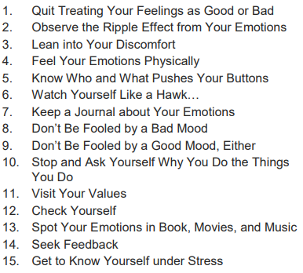 | 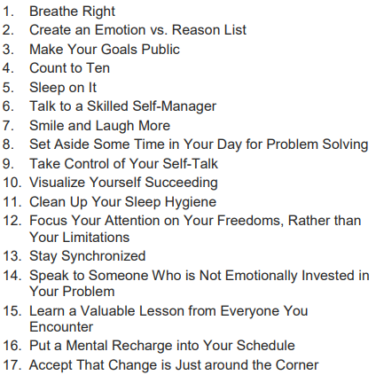
- Social Awareness Strategies | - Relationship Management Strategies
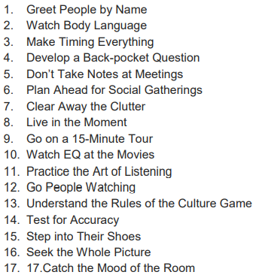 | 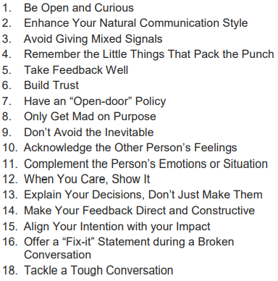

Source: Bradberry, Travis & Greaves, Jean. Emotional Intelligence 2.0. California: TalentSmart, 2009

2. ENGAGE BY COMMUNICATING POWERFULLY
To communicate powerfully, understand your audience, be intentional with your message, and identify the style that fits that audience so you can be the most effective and influential. As you plan your next presentation, use this template to prepare.
- Who is your audience? What are they interested in? What is their WIFM (what’s in it for me)? What do you want them to take away?--start with this!
- What is your message? Use the Heart –> Head –> Hands –> Hart framework I showed you. How can you customize your message to fit your audience (consider the group, age, stories, words to use, and the context of your talk).
Heart: Craft a brief heart story to connect with your audience (less than 5 minutes)

Head: Share the information that’s relevant, e.g., facts, figures, charts, etc. (main part of your message)

Hands: What is it that you want to audience to do after the presentation? (provide direction)

Heart: Craft a brief closing heart story to leave your audience inspired to take action (less than 3 minutes)

- What is your style for this presentation? Consider eye contact, body language, voice, and how formal or information the presentation is.

- Fear of rejection | - Fear of losing love | - Fear of being overwhelmed
- Fear of growing too big | - Fear of success | - Fear of making a mistake
- Fear of failure | - Fear of being exposed | - Fear of what others will think of you
- Fear of losing it all | - Fear of humiliation | - Fear of not being able to pay bills
- Fear of change | - Fear that it won't work | - Fear of not being good enough
- Fear of being vulnerable | - Fear of the unknown | - Fear of being fully authentic
- Fear of confrontation | - Fear of getting hurt | - Fear of losing your freedom
- Fear of poverty | - Fear of not fitting in | - Fear of acing your deepest truth
- Fear of criticism | - Fear of not having enough | - Fear of not doing things right
- Fear of disapproval | - Fear of my own power | - Fear of becoming greedy
*Reference: Embrace Yor Magnificence, Fabienne Fredrickson
Other fears:

What is possible on the other side of your fears? Consider what you’re giving up by staying in your comfort zone as you deliver this talk, evaluating if the cost is worth it to you:

3. IDENTIFY THE FEARS THAT HOLD YOU BACK
As you prepare to deliver a talk, if you're honest with yourself, what fears* come up for you? To influence your fears, understanding them is essential. The next step is to create a plan to step out of your comfort zone and embrace that fear to deliver an impactful talk that engages the audience and contributes positively to achieving the objectives you desire. Highlight all that apply.

3. CHECKLIST TO OVERCOME THE FEARS
As you plan to deliver a talk, go through this checklist to overcome the fears (Prepare; Be Confident; and Manage Your Energy). Do you research. Own it. Share what you know with your audience by doing your best—not being perfect. You got this!

- Prepare | - Be Confident | - Manage Your Energy
- Plan it (timeframe)  - Put it together  - Practice it (record it, use a mirror)  - Get feedback, tweak it | - Be the expert  - Be yourself  - Be physical  - Use your energy & body  - Trust yourself | - Take cleansing breaths  - Visualize success  - Reframe the fears  - Focus on gratitude

JOIN OUR COMMUNITY TO GAIN VALUABLE resources, strategies, AND TOOLS to help you REACH YOUR FULL POTENTIAL AND next level IN CAREER AND LIFE at www.executivebound.com.
ABOUT DR. GINNY A. BARO, MBA, MS, CPC

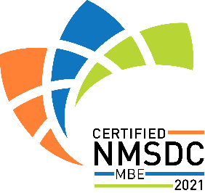 | Dr. Ginny Baro is an award-winning international transformational speaker & leadership coach, career strategist, and #1 bestselling author of Healing Leadership and Fearless Women at Work. Named one of the Top 100 Global Thought Leaders, Ginny has successfully delivered leadership coaching, training, and keynotes for Fortune 500 companies, impacting global audiences.  In 2019, Ginny created the Fearless Leadership Mastermind™, a new gold standard in leadership development, helping leaders develop a growth mindset, identify the right strategies, and take massive action consistently, with accountability in a community of growth-minded peers. The next cohort starts soon! To learn more, visit Fearless Leadership Mastermind™.  As a BONUS for being our partner and part of this journey, use PROMO CODE PWR50OFF2022 at Checkout to receive 50% off tuition ExecutiveBound scholarship while seats last. Only valid until Friday, Feb. 4th, 2022.  Ginny earned a Ph.D. in Information Systems, an MS in Computer Science, an MBA in Management, and a BA in Computer Science and Economics. She's a Certified Professional Coach (CPC) accredited by the International Coach Federation (ICF). Born and raised in the Dominican Republic until the age of 14, she is fluent in Spanish. With her programs, she and her clients impact the lives of children and families in need through Feeding American, the Unstoppable Foundation, and other charitable organizations. For more information, visit www.ExecutiveBound.com.

